**Requirement Document**

Vision:

Eserve strives to provide unique and better user experience, greatly expanding the

Impact and reach of the Seattle university far beyond the classroom. Its mission is to

Connect the campus and the wider community through sustained partnerships, in order

To deepen student learning, create a culture of service, and promote a more just and

Humane world.

Background:

The center for service and community Engagement (CSCE) at Seattle University was

founded in 2004 and connects over 1,000 students per with academic service learning

opportunities to contribute to their local community.

In order to manage the connections, class credits, evaluations, and paper work involved

with academic service learning and non- service learning , CSCE wants to custom built

the Eserve system.

Purpose:

The purpose of the product is to reduce much of the paperwork and manual interactions required to support service learning and non- service learning volunteer opportunities. It

Would fill the following business needs:

* Track team service learning projects.
* Provide a database of community volunteering opportunities
* Connect non-service learning related volunteers to opportunities in the local community.
* Collect and track demographic information
* Facilitate for the criminal background check process
* Provide user interface that is flexible, intuitive and interactive.

Project scope

1: User would be able to signup.

2 User would be able to register

3: User could search for opportunities based on different search criterion.

4: C.P’s could post and update and delete opportunities.

5 C.P.’s could evaluate volunteers.

6. C.P. could approve Student’s time entries

7. C.P’S could communicate with volunteers and admin.

8. C.P.’s could approve student’s registration.

9: Students and faculty can view student’s evaluations and self evaluation.

10. Student could enter hours of engagement.

11 Students can see opportunity status once it is approved by the Admin.

12: Admin can change the number of opportunity slots assigned to sections of the class..

13. Admin could approve/reject opportunity posted by the C.P.s.

14 Admin could generate report based on different search results.

15 User can track engagement hours.

16. Volunteers could see the communityPartnerPeople name and email associated with the opportunity.

17. Volunteers could see opportunity job hours.

18. Volunteers could see opportunity location.

19 Volunteers could see details about community partners associated with opportunity.

20 Volunteers could see opportunity requirements.

21 Alerts/Notification for pending request status, deadlines and reminders.

22. Professor could view students’s self- reflection and partner evaluation.

Not in Scope:

1.Criminal Record will not be automated in this release.

2.Experience sharing on social media will not be dealt with in this release

3.Some actors like Alumni, and Staff will be added in subsequent releases.

User Stories

User Group 1: Student

|  |  |
| --- | --- |
| User Story 1.1 | As a student, I would like to search for academic-service  learning volunteering opportunities so that I can register for a credit - granting volunteering opportunity. |
| Acceptance Criteria  (Prioritization) | * Ability to search to view current academic service learning opportunities -P0 * Ability to exclude volunteering opportunities not related to academic -service learning or credit  granting opportunities-P0 * Ability to search opportunities by category/theme-P1 * Ability to search opportunities by their distance from Seattle  University -P2 * Ability to restrict search results to just  those with open slots-P0 |

|  |  |
| --- | --- |
| User Story 1.2 | As a student, I would like to register for a volunteering  opportunity as part of academic - service learning so that I can  receive  course credit while helping others. |
| Acceptance Criteria  (Prioritization) | * Ability to select opportunity of interest from search results and continue to register -P0 * Ability to acknowledge and electronically  sign a release  form without having to print anything -P0  |  | | --- | |  |  |  | | --- | |  |  * Ability to register for the opportunity without having to re-enter demographic details stored in their profile. * Ability to receive confirmation of successful registration |

User Group 2: Admin

|  |  |
| --- | --- |
| User Story 2.1 | As an admin, I would like to receive  alerts so that  I can  finish all tasks in a timely  fashion. |
| Acceptance Criteria  (Prioritization) | * Receive student submission, approval and/or rejection for volunteer opportunity alerts-P0 * Receive new opportunity alert when posted by a partner. * Receive student under age alert when that student applies for volunteer opportunity-P0 * Receive change/update alert when an opportunity description has been updated-P0 |

|  |  |
| --- | --- |
| User Story 2.2 | As an admin, I would like to facilitate  communication  between partner and faculty to encourage the service learning programs. |
| Acceptance Criteria  (Prioritization) | * Admin can view opportunity description and notify particular faculty member-P0  |  | | --- | |  |  * Faculty member may communicate with partner via  the system which is transparent to the Admin- P0 |

|  |  |
| --- | --- |
| User Story 2.3 | As an admin, I would like to facilitate slots of an opportunity to different classes to give  students of  different classes a chance to participate in the  opportunity. |
| Acceptance Criteria  (Prioritization) | * Admin can view opportunity description and edit  the numbers of slots-P0 * Admin can choose from list of potential classes to distribute the slots-P0  |  | | --- | |  |  * Faculty and partner are notified via e-mail about the changes. |

User Group 3: Partner

|  |  |
| --- | --- |
| User Story 3.1 | As a partner, I would like to add/edit volunteering  opportunities/slots available in my organization in the eserve 2.0 system. |
| Acceptance Criteria  (Prioritization) | * Ability to add volunteering opportunities-P0 * Ability to edit opportunities-P0 * Ability to add/edit open slots for each opportunity I post-P0 * Ability to filter my search to view current  volunteering opportunities posted by my organization-P1 |

|  |  |
| --- | --- |
| User Story 3.2 | As a partner, I would like to be able to accept/reject students |
| Acceptance Criteria  (Prioritization) | * Ability to reject students if they don’t fulfill the prerequisites that I posted when they applied for the opportunity-P0 * Ability to accept students applications-P0 |

|  |  |
| --- | --- |
| User Story 3.3 | As a partner, I would like to be able to  evaluate students |
| Acceptance Criteria  (Prioritization) | * Ability to input no. of hours the student worked-P1 * Ability to write a short text description on how the student worked/performed-P1 |

|  |  |
| --- | --- |
| User Story 3.4 | As a partner, I would like to be able to view course syllabus /information/hours required. |
| Acceptance Criteria  (Prioritization) | * Ability to view courses that are being offered  in the current quarter-P1 * Ability to view course syllabus/volunteering hours needed for the course-P1 |

User Group 4: Faculty

|  |  |
| --- | --- |
| User Story 4.1 | As a faculty, I would like to communicate(via e-mail) with community partners |
| Acceptance Criteria  (Prioritization) | * Ability to email community partners to learn more about volunteering opportunities/student evaluation/general queries related to volunteering opportunity-P1 |

|  |  |
| --- | --- |
| User Story 4.2 | As a faculty, I would like to get e-mail alerts for pending requests,monitoring/approving student service hours and new messages from anyone who has access to the system. |
| Acceptance Criteria  (Prioritization) | * Ability to receive email alerts/emails -P1 |

User Group 5: Alumni

|  |  |
| --- | --- |
| User Story 5.1 | As an alumni, I would like to search for service  learning volunteering opportunities so that I can register for a granting volunteering opportunity. |
| Acceptance Criteria  (Prioritization) | * Ability to search to view current service learning opportunities -P0 * Ability to exclude volunteering opportunities  related to academic -service learning or credit  granting opportunities-P0 * Ability to search opportunities by category/theme-P1 * Ability to search opportunities by their distance from Seattle  University -P2 * Ability to restrict search results to just  those with open slots-P0 |

|  |  |
| --- | --- |
| User Story 5.2 | As an alumni, I would like to register for a volunteering  opportunity as part of service learning so that I can help others. |
| Acceptance Criteria  (Prioritization) | * Ability to select opportunity of interest from search results and continue to register -P0 * Ability to acknowledge and electronically  sign a release  form without having to print anything -P0  |  | | --- | |  |  |  | | --- | |  |  * Ability to register for the opportunity without having to re-enter demographic details stored in their profile. * Ability to receive confirmation of successful registration |

Non- Functional requirements:

Security Requirement

SE-1: All users must be authenticated to Seattle University network with a valid Seattle University    ID.

SE-2: All communication shall be encrypted using a secured socket layer (SSL).

SE-3: Users able to log-out from the system.

Privacy Requirements:

PR-1: Results of the background investigation are only visible to admins.

PR-2: Student feedback is only visible to faculty and that student.

Usability Requirements:

US-1: Student can query through all volunteering opportunities based on relevant parameters all on one screen.

US-2: The menu structure is intuitive and users can find their desired subsection in less than 5 seconds.

US-3: Community partners are able to CRUD volunteering opportunities without engaging the system admin.

Reliability Requirements:

RE-1: System shall have a minimum uptime of 99%

RE-2: System data is backed up daily.

Design Requirements:

DE-1: System shall adhere to Seattle University's style and content guidelines.

DE-2: System shall be developed on .NET Stack

Other Requirements:

OR-1: System must interface with criminal records check and keep an encrypted record of the results only accessible by the system admin.

OR-2: Users can retrieve past feedback and volunteering records for as long as the Seattle University ID account is valid.

Opportunity State diagram:

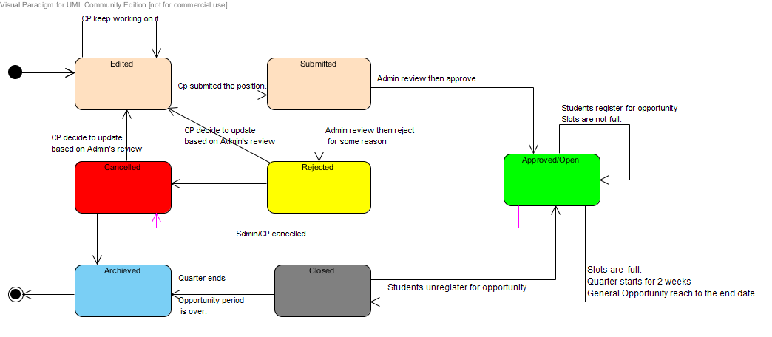

System diagram:

 Figure 1: System Diagram

Assumptions and dependencies:

Assumptions:

* The office of Information Technology will both support ongoing operations of the tool, as well as sustained engineering.

Dependencies:

* Eserve should pull data from and integrate with SUDDS, a data distribution platform for Seattle University.
* Eserve should integrate with Seattle University’s chosen criminal records check provider.